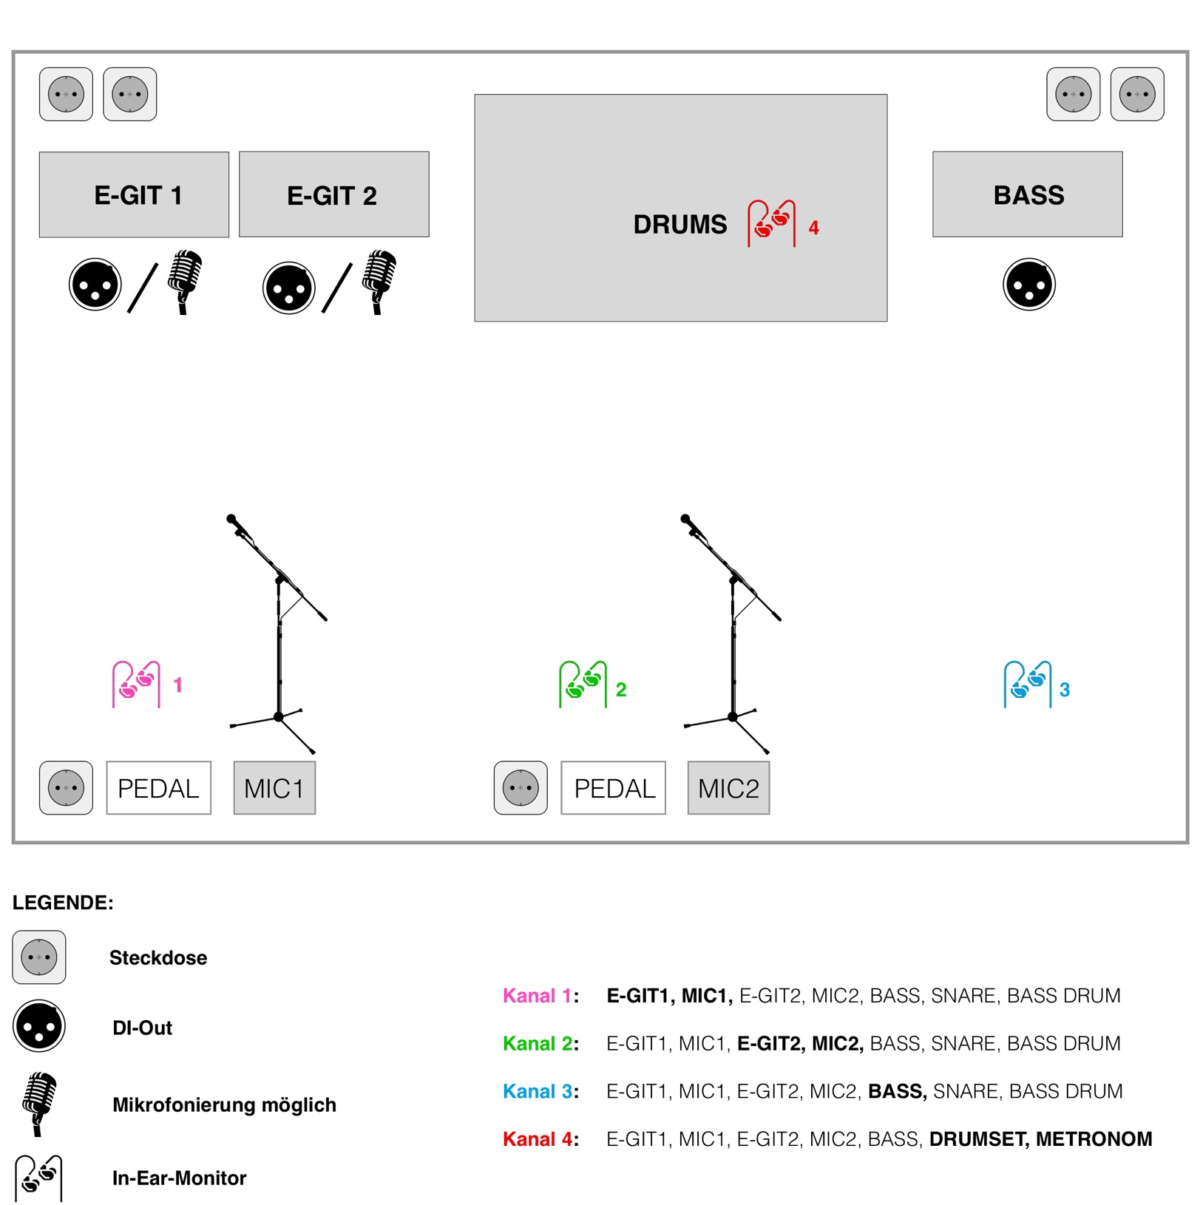

Kanal |  |  | Kanal
1 | BASSDRUM |  | 9 | E-GIT 1
2 | SNARE |  | 10 | E-GIT 2
3 | STANDING TOM |  | 11 | BASS
4 | HANGING TOM1 |  | 12 | MICROPHONE 1
5 | HANGING TOM2 |  | 13 | MICROPHONE 2
6 | OVERHEAD L |  | 14 | -
7 | OVERHEAD R |  | 15 | CLICKTRACK (NUR IEM)
8 | - |  | 16 | BACKINGTRACK

